

Supplementary Materials for

**Avoiding tradeoffs between global seafood production and seafloor impacts through fishery innovation**

T. Scott Smeltz1,2*, Christopher M. Free3, Bradley P. Harris2, Olaf P. Jensen4, Jonathan H. Grabowski5, Suresh A. Sethi2,6

Correspondence to: [ts428@cornell.edu](mailto:ts428@cornell.edu)

**This PDF file includes:**

Materials and Methods

Supplementary Text

Figs. S1 to S2

Table S1 to S2

Materials and Methods

Seafloor disturbance model

Seafloor disturbance was estimated using a spatiotemporal model that incorporates impact and recovery dynamics to track the proportion of disturbed and undisturbed areas within grid cells over discrete time steps. The full model is detailed in Smeltz et *al.* (*12*). We used a 2 km x 2 km grid over monthly time steps for these analyses, limiting the domain to the world’s continental shelves, defined here as depths from 0 m - 1,000 m. Impacts are defined as the proportional amount of undisturbed seafloor within a grid cell that transitions to a disturbed state over a time step. Disturbances are calculated for each grid cell and time step as the product of the total swept area ratio (SAR), gear contact adjustment, and habitat susceptibility, which is then adjusted to account for overlapping effort on the assumption that fishing effort is randomly distributed within a grid cell and time step. The SAR is the summed footprint of all trawl activity within the grid cell and time step; contact adjustment is the proportion of the footprint that contacts the seafloor; susceptibility is the proportion of habitat features that would be disturbed by contact. In the main text, contact adjustment is referred to in terms of contact reduction for ease of interpretation, where contact reduction is the complement of contact adjustment ($contact reduction=1-contact adjustment$). Recovery is the proportional amount of disturbed seafloor that transitions back to an undisturbed state and is parametrized in this analysis by the mean time required for seafloor habitats to recover from to 5% to 95% of their pre-disturbance levels. The susceptibility and recovery parameters are based on the seafloor habitat types within a grid cell from a global benthic habitat database described below.

Fishing effort and gear parameters

Fishing effort data was provided by Global Fishing Watch (<https://globalfishingwatch.org/>) which they compiled from AIS data using a neural network to identify vessel type and behavior (e.g. fishing or transiting)(*9*). We acquired the data as daily hours fished by gear type on a 0.01-degree grid for 2013 – 2018. Our seafloor impact analyses included only effort designated as trawlers. The effort data was aggregated to an equidistant 2 km x 2 km raster grid on monthly time steps. Fishing hours in each grid cell and time step were converted to SAR as: $SAR=\left(fishing hours\right)x\left(speed\right)x\left(gear width\right)/(grid area)$. Gear towing speeds were set at 7.408 km hr-1 (4 knots), following the average speed used to detect trawler fishing activity in the AIS data(*9*). Gear width was set to 200 m for all effort, a conservative impact estimate at the global scale, corresponding to the upper range of trawl widths (*33*).

Susceptibility and recovery of seafloor habitats

The recovery rate and susceptibility of seafloor habitats was based on the habitat type of each grid cell. Global maps of seafloor habitats (*34*) were acquired from the National Center for Ecological Analysis and Synthesis. The downloaded maps were resampled to the 2 km x 2 km grid and aggregated into three broad habitat categories (soft substrate, hard substrate, and rocky reef) to align with habitat categories employed by the habitat vulnerability meta-analysis used to parameterize recovery (*11*, *35*, *36*). Susceptibility was set to 0.3 for all habitat types following the findings of Grabowski et *al.* (*11*).

Recovery of seafloor habitats was parameterized as the time to recover from 5% to 95% ($τ^{*}$) following an asymptotic recovery trajectory. Three benthic recovery meta-analyses (*11*, *35*, *36*) were used parameterize $τ^{*}$ for soft, hard, and rocky reef seafloor habitat types. However, each of these analyses employed different recovery trajectories in their estimation of recovery. Grabowski et *al*. (*11*) reported the mean time to recovery, $\overline{τ}$; Hiddink et *al*. (*35*) estimated an intrinsic growth rate, $r$, of a logistic recovery curve; and Graham et *al.* (*36*) reported the yearly proportional recovery, $C_{rp}$, along a linear recovery path, equivalent to the slope of the recovery line. In order to standardize recovery rates across these analyses, we calculated $τ^{*}$ from each of the respective recovery functions. In the following equations we set $H_{0}=0.05$ and $H_{1}=0.95$, representing recovery from 5% to 95%.

The Hiddink et *al*. $r$ parameter (*35*) was converted as:

|  |  |  |
| --- | --- | --- |
|  | $$τ^{*}=-\frac{1}{r}\log\left(\frac{\frac{1}{H_{1}}-1}{\frac{1}{H_{0}}-1}\right)$$ | (S.1) |

The Graham et *al*. $C_{rp}$ parameter (*36*) was converted as:

|  |  |  |
| --- | --- | --- |
|  | $$τ^{*}=\frac{H_{1}-H_{0}}{C_{rp}}$$ | (S.2) |

The Grabowski et *al*. $\overline{τ}$  parameter (*11*) was converted to recovery parameter $\overline{τ}$ then calculated from $τ^{*}$ as follows:

|  |  |  |
| --- | --- | --- |
|  | $τ^{*}=τ[\log\left(1-H_{0}\right)-log⁡(1-H_{1})$] | (S.3) |

We generally employed conservative estimates of susceptibility and recovery parameters, using the slowest recovery rates reported by these meta-analyses: 9.6 years for soft substrates, 9.1 years for hard substrates, and 25.3 years for rocky reefs.

Table S1. Reported recovery times from meta-analyses

|  |  |  |  |  |
| --- | --- | --- | --- | --- |
| Habitat type | Source | Reported value | Description of value | $τ^{*}$ equivalent  (years to recover from 5% to 95%) |
| Soft substrate | Hiddink et *al.* (*35*) | $$r=0.82$$ | Recovery to pre-trawl biomass | 7.2 |
| $$r=1.05$$ | Recovery to pre-trawl abundance from otter trawls | 5.6 |
| $$r=4.49$$ | Recovery to pre-trawl abundance from beam trawls | 1.3 |
| Grabowski et *al.* (*11*) | $$\overline{τ}=3.25$$ | High energy mud habitats | 9.6 |
| $$\overline{τ}=3.13$$ | High energy sand habitats | 9.2 |
| $$\overline{τ}=3.00$$ | High energy granule/pebble habitats | 8.8 |
| $$\overline{τ}=3.29$$ | Low energy mud habitats | 9.7 |
| $$\overline{τ}=3.17$$ | Low energy sand habitats | 9.3 |
| $$\overline{τ}=3.14$$ | Low energy granule/pebble habitats | 9.3 |
| Hard substrate | Grabowski et *al.* (*11*) | $$\overline{τ}=2.95$$ | High energy cobble habitats | 8.69 |
| $$\overline{τ}=2.91$$ | High energy boulder habitats | 8.57 |
| $$\overline{τ}=3.10$$ | Low energy cobble habitats | 9.13 |
| $$\overline{τ}=3.06$$ | Low energy boulder habitats | 9.01 |
| Rocky reef | Graham et *al.* (*36*) | $$C_{rp}=0.0356$$ |  | 25.28 |

Model runs

Three types of model runs were used in these analyses: 1) initial condition burn-in, 2) baseline model runs, and 3) forward projection scenarios. To create reasonable initial conditions of seafloor disturbance for the start of the baseline model, we first conducted a “burn-in” model run. This entailed setting seafloor disturbance to 0% for all grid cells domain-wide for the initial conditions of the burn-in and randomly selecting and applying effort levels from all available years of fishing effort data for each respective month (e.g., for each January in the burn-in, a random January realization of effort was selected from 2013-2018). This burn-in was run for 30 years to allow ample time for seafloor disturbance to equilibrate under effort levels representative of current fishing levels.

Next, the baseline model was run using the final month results of the burn-in as its initial conditions. The baseline model was run using monthly fishing effort data in consecutive order from 2013 - 2018. Results presented in the main text reflect the estimates for December 2018, the terminal month of the fishing effort data. Based on discussions with the data providers, some LMEs, particularly at lower latitudes, were known to have low AIS coverage of their trawl fisheries. We identified ten LMEs as likely to have low AIS coverage of their bottom-tendered gear fleets by identifying LMEs that were univariate outliers in their ratio of 2014 total harvest to fishing effort (Fig. S1). We upward adjusted estimated seafloor disturbance for these LMEs using k-means clustering to group all LMEs into ten catch groups based on their harvest profiles (proportional harvest of functional groups). For each catch group, we used a linear model relating logit-transformed seafloor disturbance (%) to logged total harvest (mt year-1) using the remaining LMEs with high AIS coverage. Adjusted estimates for the low coverage LMEs were then estimated from these models. At the global scale, this increased estimated seafloor disturbance from 2.9 million km2 (unadjusted estimated) to 3.4 million km2 (adjusted estimate, reported in main text), a 13% increase (see Table S1 for LME-specific adjusted values). These effort-adjusted LMEs were excluded from subsequent harvest and contact adjustment scenario analyses.

Four forward projection scenarios were conducted: 1) current fishing effort, 2) MSY fishing effort, 3) current fishing effort with contact reduction, and 4) MSY fishing effort with contact reduction. The terminal month of the baseline model was used as initial conditions for all forward projection model runs. For each run of the forward projection scenarios, fishing effort for each month was randomly selected from all available years (same process as the random selection for the initial condition burn-in). In the current fishing effort scenario, we drew directly from the realized fishing data. The MSY scenario adjusted the realized fishing data with an LME-specific parameter representing the ratio of estimated fishing effort at MSY to baseline fishing effort ($E_{msy}/E_{base}$). The contact adjustment scenarios used realized fishing effort, but adjusted impacts over a range of contact reductions (0%, 10%, 20%, 30%, 40%, and 50%). The MSY fishing with contact reduction was a combination of the two scenarios. These forward projections were each run for 30 years, using the mean of the last 15 years as reported values. Uncertainty in these estimates was calculated from the standard error of these means, and reflect the variability in year-to-year fishing effort intensity and spatial distribution of fishing effort. All reported estimates of relative change in seafloor disturbance for the MSY, contact reduction, and MSY/contact reduction scenarios are relative to the current fishing effort scenario.

MSY forward projection scenarios

Running the MSY scenarios required estimation of the $E_{msy}/E_{base}$ ratio for each LME as well as estimating fishery yield at MSY. This required first estimating the exploitation rate, $U$, and standing biomass, $B$, for trawl caught stocks both at MSY ($U_{msy}, B_{msy}$) and baseline levels ($U_{base}, B_{base}$). We estimated these parameters using Robin-Hood cMSY (RH-cMSY) (*23*), an adaptation of the catch-MSY catch-only stock assessment method (*37*, *38*), to assess marine fish and invertebrate stocks in the Sea Around Us Database (*6*). We defined stocks as LME and species combinations and evaluated the 2,070 stocks with at least 20 years of reported catch data and more than 1,000 mt of maximum reported catch, which captured 54.6% of global reconstructed trawl catch.

RH-cMSY is based on the cMSY (*38*) stock reduction analysis but uses information from data-rich stocks to set priors for data-poor stock parameters. In general, both methods reconstruct historical abundance and exploitation rates by simulating biomass trajectories that could feasibly produce the observed catch time series given assumptions about initial and final year depletion and population parameters such as carrying capacity, *K* and intrinsic growth rate, *r*. RH-cMSY primarily differs from cMSY in that it uses meta-analyses of data-rich stocks in the RAM Legacy Stock Assessment Database (*39*) to set priors for all four values. Furthermore, it uses a Pella-Tomlinson rather than a Schaefer surplus production model to account for asymmetry in production (*40*) and does not use the “tip of the triangle” assumption employed in cMSY.

Yield for each stock in the MSY scenarios was calculated from the $U_{msy}$ and $B_{msy}$ parameters estimated in the RH-cMSY analysis as: $Y_{msy}=U_{msy}B_{msy}$. Yield for the LME was the sum of the yield from all stocks within the LME. However, this only reflects the data- rich stocks included in the RH-cMSY analysis, thus the percent change in yield at MSY over baseline conditions presented in the main text reflects only these stocks. Estimations of total yield at MSY (mt year -1) presented in the main text apply this percent change to the total LME-wide baseline yield.

Estimating $E_{msy}/E_{base}$ began from the basic fishery equation relating yield, effort, stock biomass, and catchability, $q$: $Y=qEB$. Solving for $E$ then gives the ratio as follows:

|  |  |  |
| --- | --- | --- |
|  | $$\frac{E_{msy}}{E_{base}}=(\frac{Y_{msy}}{q_{msy}B_{msy}})(\frac{q_{base}B_{base}}{Y_{base}})$$ | (S.4) |

To estimate this ratio, a relationship between catchability at MSY and baseline conditions is needed. As a simplifying assumption we assumed that catchability at MSY is equal to that at baseline conditions ($q_{msy}=q_{base}$), reducing eq. (S.4) to:

|  |  |  |
| --- | --- | --- |
|  | $$\frac{E_{msy}}{E_{base}}=(\frac{Y_{msy}}{B_{msy}})(\frac{B_{base}}{Y_{base}})$$ | (S.5) |

Additionally, because $E_{msy}/E_{base}$ is used at the level of the LME, the yields and stock biomasses in eq. (S.5) reflect the sum of these values across an LME for stocks included in the RH-cMSY analysis.

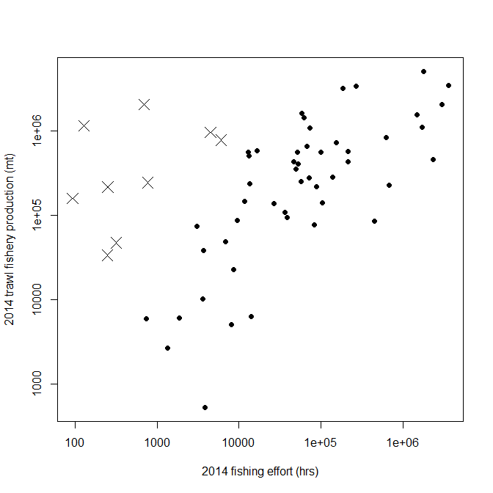

Fig. S1. Relationship between 2014 bottom-tendered fishery production (mt) and fishing effort (hrs) for large marine ecosystems (LMEs). The X’s signify LMEs that were identified as outliers in their ratio of production: effort (suggesting missing fishing effort) and consequently had adjustments made to their estimates of seafloor disturbance.

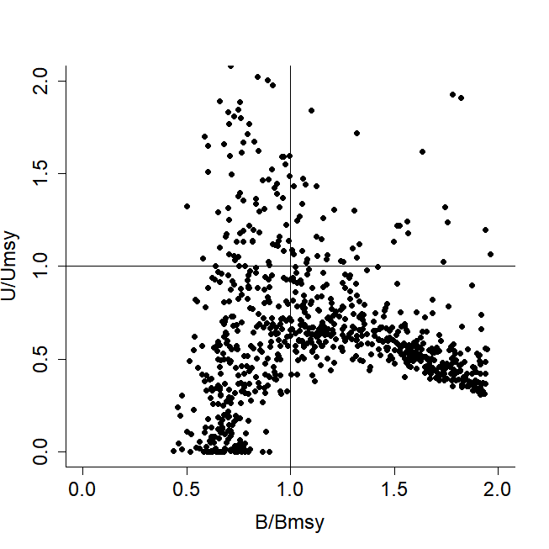

Fig. S2. Status of global bottom-tendered gear fisheries showing exploitation rate and stock biomass relative to MSY of stocks estimated using the RH-cMSY catch-only assessment model. The vertical axis is the ratio of current exploitation rate to that at MSY ($U/U_{MSY}$). The horizontal axis is the ratio of current stock biomass to that at MSY ($B/B_{MSY}$). Fisheries in the upper left quadrant are currently overexploited and have stock biomasses below those associated with MSY, indicating opportunities for which reductions in fishing effort could both increase harvests and stock sizes, as well as reduce seafloor impacts. In contrast, underexploited fisheries below the horizontal $U/U_{MSY}$ = 1.0 line would require increases in fishing effort to achieve MSY and thus may increase seafloor disturbances under conventional fishing practices.

Table S1. Seafloor disturbance, harvests, and estimated maximum sustainable yields for trawl fisheries by large marine ecosystem (LME).

| **LME** | **Seafloor disturbance (%)** | **Shelf area**  **(sq. km)** | **2014 trawl harvest (1,000 mt)** | $E_{msy}/E_{last}$* | $Y_{msy}/Y_{last}$† |
| --- | --- | --- | --- | --- | --- |
| Agulhas Current | 7.2 | 470,184 | 108.9 | 0.87 | 1.25 |
| Aleutian Islands | 6.8 | 83,264 | 508.1 | 1.85 | 1.13 |
| Antarctic | 0.2 | 2,721,116 | 146.7 | 1.85 | 1.08 |
| Arabian Sea | 1.9 | 861,776 | 584.5 | 2.28 | 1.42 |
| Baltic Sea | 20.2 | 377,548 | 436.4 | 1.77 | 1.42 |
| Barents Sea | 14.3 | 1,793,564 | 229.3 | 1.55 | 1.67 |
| Bay of Bengal | 0.5 (15.5)‡ | 897,204 | 2,072.5 | 1.89 | 1.27 |
| Beaufort Sea | 0.1 | 620,780 | 0 | -§ | - |
| Benguela Current | 17.1 | 400,664 | 1,095.2 | 1.25 | 1.27 |
| Black Sea | 5.8 | 190,820 | 355.9 | 1.3 | 1.46 |
| California Current | 10.9 | 206,296 | 407.3 | 1.55 | 1.21 |
| Canadian Eastern Arctic -West Greenland | 3.6 | 1,004,632 | 141.8 | 1.1 | 1.25 |
| Canadian High Arctic - North Greenland | 0 | 372,060 | 0 | - | - |
| Canary Current | 22.9 | 269,340 | 3,229.3 | 1.71 | 1.24 |
| Caribbean Sea | 0 (2.5) ‡ | 850,176 | 33.8 | 1.41 | 1.55 |
| Celtic-Biscay Shelf | 45.9 | 591,924 | 1,109.8 | 1.41 | 1.25 |
| East-Central Australian Shelf | 5.7 | 87,520 | 5.1 | 3.46 | 4.47 |
| East Bering Sea | 14.3 | 633,352 | 735.9 | 1.59 | 1.12 |
| East Brazil Shelf | 0.2 (4.2) ‡ | 200,136 | 38.7 | 1.59 | 1.27 |
| East China Sea | 20.2 | 682,420 | 3,489.5 | 1.43 | 1.29 |
| East Siberian Sea | 0 | 612,960 | 0 | - | - |
| Faroe Plateau | 34.1 | 87,984 | 287.3 | 1.24 | 0.92 |
| Greenland Sea | 3.1 | 561,164 | 77.1 | 1.74 | 1.92 |
| Guinea Current | 17.8 | 377,376 | 1,624.7 | 1.95 | 1.44 |
| Gulf of Alaska | 8.9 | 441,872 | 565.0 | 1.29 | 1.19 |
| Gulf of California | 0.3 (7.1) ‡ | 125,020 | 160.5 | 1.74 | 1.16 |
| Gulf of Mexico | 5.5 | 726,084 | 566.3 | 1.18 | 1.08 |
| Gulf of Thailand | 0.8 (14) ‡ | 381,072 | 1,163.6 | 1.4 | 1.31 |
| Hudson Bay Complex | 0.2 | 1,234,880 | 0.5 | - | - |
| Humboldt Current | 2.8 | 403,220 | 139.0 | 1.73 | 1.83 |
| Iberian Coastal | 44.5 | 88,436 | 86.3 | 1.3 | 1.51 |
| Iceland Shelf and Sea | 24.9 | 286,752 | 575.6 | 1.95 | 1.9 |
| Indonesian Sea | 0.1 (13.2) ‡ | 1,136,496 | 968.5 | 1.69 | 1.18 |
| Insular Pacific-Hawaiian | 0.1 | 52,192 | 0 | - | - |
| Kara Sea | 0.4 | 923,308 | 0 | - | - |
| Kuroshio Current | 6.9 (12.3) ‡ | 227,912 | 782.3 | 1.08 | 1.33 |
| Laptev Sea | 0.1 | 818,764 | 0 | - | - |
| Mediterranean Sea | 25.7 | 1,035,708 | 461.9 | 1.46 | 1.3 |
| New Zealand Shelf | 7.5 | 546,724 | 278.4 | 1.43 | 1.15 |
| Newfoundland-Labrador Shelf | 4.4 | 868,248 | 253.2 | 1.29 | 1.86 |
| North Australian Shelf | 1.5 | 771,604 | 22.9 | 1.13 | 1.26 |
| North Brazil Shelf | 1.4 | 519,492 | 94.0 | 1.69 | 1.43 |
| North Sea | 37.8 | 667,836 | 1,572.5 | 0.94 | 1.1 |
| Northeast Australian Shelf-Great Barrier Reef | 1.6 | 496,736 | 6.3 | 0.98 | 1.23 |
| Northeast U.S. Continental Shelf | 11.8 | 307,664 | 561.9 | 1.23 | 1.38 |
| Northern Bering - Chukchi Seas | 2.2 | 1,159,852 | 240.3 | 1.68 | 1.16 |
| Northwest Australian Shelf | 0.9 | 508,748 | 10.3 | 1.31 | 1.3 |
| Norwegian Sea | 14.4 | 217,312 | 218.8 | 1.68 | 1.45 |
| Oyashio Current | 25.9 | 101,540 | 663.9 | 1.1 | 1.12 |
| Pacific Central-American Coastal | 0 (8.2) ‡ | 298,504 | 246.2 | 0.96 | 1.14 |
| Patagonian Shelf | 14.6 | 1,137,476 | 848.9 | 1.35 | 1.17 |
| Red Sea | 0 (4.5) ‡ | 387,040 | 47.5 | 1.85 | 1.61 |
| Scotian Shelf | 2.1 | 277,256 | 49.0 | 1.51 | 2.05 |
| Sea of Japan / East Sea | 9.3 | 369,320 | 1,454.1 | NA | NA |
| Sea of Okhotsk | 14.5 | 1,063,660 | 3,418.0 | 1.49 | 1.35 |
| Somali Coastal Current | 1.4 | 136,572 | 87.4 | 2.59 | 1.48 |
| South Brazil Shelf | 8.2 | 347,128 | 74.8 | 1.38 | 1.23 |
| South China Sea | 6.6 | 1,727,392 | 5,149.6 | 1.52 | 1.18 |
| Southeast Australian Shelf | 1.3 | 239,984 | 6.1 | 2.48 | 3.64 |
| Southeast U.S. Continental Shelf | 1.9 | 297,204 | 38.8 | 1.21 | 1.48 |
| Southwest Australian Shelf | 1.3 | 347,704 | 6.0 | 1.81 | 2.28 |
| Sulu-Celebes Sea | 0 (7.9) ‡ | 346,416 | 217.9 | 2.02 | 1.34 |
| West-Central Australian Shelf | 2.1 | 167,408 | 2.7 | 1.63 | 2.06 |
| West Bering Sea | 24 | 154,720 | 438.9 | 1.22 | 1.04 |
| Yellow Sea | 41.1 | 430,080 | 2,055.6 | 1.74 | 1.22 |
| Central Arctic | 0 | 22,772 | 0 | - | - |

*Ratio of effort needed to achieve MSY relative to the last year of catch data (2014), estimated by the RH-cMSY catch-only model.

†Ratio of yield needed at MSY relative to the last year of catch data (2014), estimated by the RH-cMSY catch-only model.

‡Numbers given in parentheses indicate adjusted estimates of seafloor disturbance due to low AIS coverage.

§Dashes (-) indicate insufficient data to calculate.